The Christian Community
Movement for Religious Renewal

Denver Program for September to Christmas 2020

The Act of Consecration of Man
Sundays at 11:00 a.m.*
*(Note! Beginning Nov. 1, at 10:30 a.m)*

The Sunday Service for Children
Is offered every Sunday at 10:30 a.m.*
*(Note! Beginning Nov. 1 at 10:00 a.m.)*

Religious Instruction for Children
Offered every Sunday at 10:00 a.m.*
*(Note! As of Nov. 1, at 9:30 a.m.)*
Please inform Rev. Hindes
if you will be bringing your child.

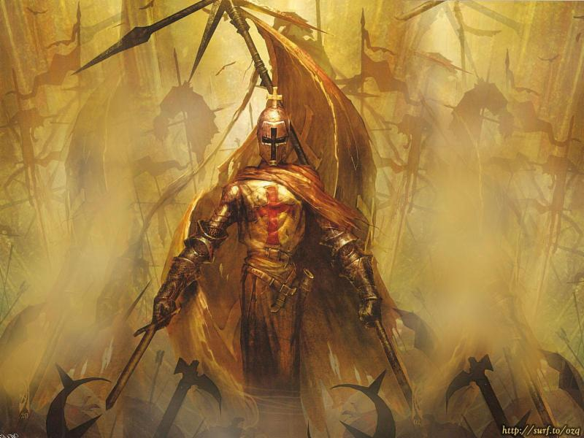
The Archangel Against the Demons of our Time.

Michael Sophia Chapel
2180 South Madison
Denver, CO 80210
www.thechristiancommunity.org

The Sacrament of Confirmation
Sunday, September 27, 11 am
Celebrate this coming of age sacrament for Wyatt Carr, Megan Blanning and Garrison Kakos
There is No Sunday Service for Children.

September 29, Michaelmas Day, Tuesday

9:00 am The Act of Consecration of Man

October 4, The First Sunday of Michaelmas

Michaelmas Festival Garden for Children
9:45 am Michaelmas Festival – Singing, story, and an interactive pageant for the children – each should bring a flower and will receive a gift.
10:30 am The Sunday Service for Children
11am The Act of Consecration of Man

October 12 to October 16 Rev. Hindes will be attending the North American synod in Devon, PA. As always, he can be reached by phone 303 981 8774.

October 25, The Fourth Sunday of Michaelmas
12:15 pm Rev. Hindes will speak on: Who is Michael the Archangel? An answer is found in The King and the Corpse, an ancient Hindu legend that reveals the essence of Christianity. Story time for adults!

November 1, Sunday: Two Things of Importance!
One: The time for Services on Sunday morning and every morning thereafter moves back 30 minutes. Act of Consecration will be at a10:30 am, etc.

Two: Daylight Savings Time will have ended by Sunday morning. Set your alarms to 2:00 am to wake up and move your clock dials back one hour. Or wait till morning, or do it the night before. If you forget you may come to church half an hour early!

November 8, Sunday
10:00 am Children’s Puppet Show

November 22, Sunday
12:15 pm Remembering our Dead. A gathering to remember members and friends of The Christian Community who have passed over the threshold.

The First Sundays of Advent
November 29, Sunday & December 6, Sunday
After the services Rev. Hindes will speak on
God’s Ten Statements in Genesis concering Human Life, Pt. 1& 2
These words have determined the laws of biography ever since.

December 13th The Third Sunday of Advent
9:45 am ADVENT GARDEN FOR CHILDREN. The Spiral of Life begins anew in the Christian year at Advent, the season that makes Christmas possible. The children will walk to the center, spiraling inward to the source of the light; then bearing their flame they will place their candle on the path to illuminate the way into the future. All are welcome.

Threefold Christmas Service
Monday, Dec. 25, beginning at 12 midnight Dec. 24.
I. Midnight Service
II. 8:00 am Sunrise Service
Potluck breakfast for those who wish to stay
between the sunrise and day service
10:00 am Christmas Service for Children
In this service, the meaning of Christ’s coming is brought into the present with beautiful pictorial language placed before the Child.
III. 10:30 am Christmas Day Service

The Twelve Days of Christmas
The Act of Consecration of Man is celebrated each of the twelve days (Dec. 25 – January 5), after Christmas Day at 9 am, on Sundays Dec. 27 & Jan. 3 at 10:30 am.

12:30 pm
The Incarnation of the Logos:
An Epic Tale of
Christ's Coming to Earth

Told by Glen Williamson
The Incarnation of the Logos harmonizes the conflicting nativity accounts of the Gospels of Matthew and Luke and weaves the threads of many traditions into an intimate but also cosmic drama. Adam and Eve, Moses, Adonis, Osiris, Isis, Apollo, Krishna, Buddha and Zarathustra all appear in this sometimes-astonishing retelling of the greatest story ever told. This saga is based on the Gospels and the work of spiritual researcher Rudolf Steiner.

Eleventh Annual New Year’s Gathering
Thursday, December 31, 2020
6pm Formal Potluck Dinner ~ Jacket and Tie Required
Close of Day Service with Sermon to end our evening
There are thespian plans afoot for the time after the meal. Stay tuned.
You too may get a phone call. Please RSVP at 303-981-8774

Our resident priest is:
Rev. James H. Hindes
(303) 981-8774
You can phone him anytime!

The Christian Community is entirely supported by the contributions of its members and friends.

Michael Sophia Chapel
2180 South Madison
Denver, CO 802

